# 

# Return to Space

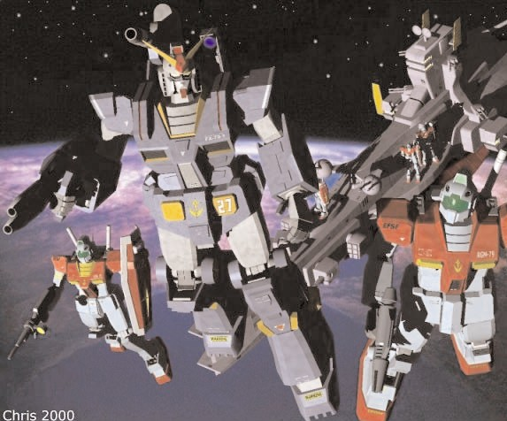

# A Brief Introduction

This Mobile Suit Gundam Battle System - Return to Space is an expansion for the Mobile Suit Gundam Battle Strategy system allowing you to fight deep space battles on the tabletop between your Gundam and Mobile suit action figures or Model kits. You will need a copy of the Mobile Suit Gundam Battle System Core Rules to use the expansion presented here.

The Return to Space is a follow up supplement to the Ground War rules represented in the core MSGBS. This time we move into a new direction and into the harsh and disorientating combats that took place in space. Now you can send your own teams of Mobile Suits into the sea of stars. Taking command of Federation Mobile Suit wing or units of the Zeon Mobile forces. The RtS expansion also introduces two new units to the mix, Space Fighters and Mobile armors (Mobile armors will be released with their own datasheets!).

Now before I go here is a very important note; the Return to Space rules is not a rework of the MSGBS. Points made in those plug-in rules unless mentioned here still apply. Also unless it’s mentioned in the plug-in rules follow all the rules for shooting, combat and movement that the core rulebooks. Have fun...

# Rolling for Initiative

The turns in MSGBS are divided into three phases - Movement, Shooting and assault on the ground rules each player went through his phases then it was the other player’s turn. In space things move a lot quicker, it’s easier to lose sight of your opponent in the depths of space or be disorientated by the openness of the combat. Both players now take their turn at the same time and must roll a D6 at the start of each phase - the highest scorer then chooses if he wants to go first or second.

For example: *It’s the movement phase, Mark and Henry roll a D6 each, Mark scores a 3, while Henry scores a 4. Henry wins the Initiative and can now choose to move first or second. The shooting phase is next and again they roll off, this time Mark wins and chooses to shoot first.*

# Movement

The biggest change in the Return to Space or (RtS) is the movement values. In the Ground War set all suits moved pretty much at the same speed, in space some suits are faster, more agile or more over- powered than others. Therefore all Mobile Suits now have their own individual movement characteristic which is recorded on the suit profile. This represents how agile the suit and how well it can move in the gravity free environment of space

However, no matter how free the movement is in Space, all suits still have to combat inertia, g-forces and the fact that everything in space is moving all the time. Here are the general rules governing movement and turning in space.

|  |
| --- |
| Mobile Suits  May turn at any time, the movement cost to turn is set out below. |
| 2” to turn 45° |
| 3” to turn 90° |
| 5” to turn 180° |

For example: *A GM’s move rate is 12” - the Pilot uses 6” inches to boost forwards towards a piece of Space debris and then executes a 90 degree turn which costs him an additional 3” movement - taking the total to 9”. The last 3” are used to boost the suit behind the Space debris.*

Note - *Space is a 3D combat environment apart from turning and keeping station. A Mobile suit may find itself flying up and over terrain. Measure the distance it take the suit to climb the obstacle vertically and subtract it from the movement (vertical movement does counts as straight line movement for working out modifiers). If the suit doesn’t clear in that turn, it can be assumed it is still climbing and will finish its ascent in the next turn.*

**Keeping Station**

There are weapons that are fired which require a Mobile Suit to stay still, or maybe they are keeping station. The Suit doesn’t move and all its movement is used up to keep it in place. A suit that keeps station cannot assault in the assault phase.

**Fullburn**

Mobile Suits are designed with sophisticated inertia systems which cut in to stop the pilot from becoming a bloody stain in this cockpit, if he accelerates too hard. The speeds represented on the Mobile Suits profile is its ‘safe’ combat speed. Mobile Suits are capable of pushing way past their safety limits if the pilot chooses to override his inertia controls. To do this the Pilot must make a successful PS, he can then add an additional 2D6” to his movement.

For that turn the Mobile Suit moves its full distance including its Fullburn movement in one direction, it cannot turn, shoot, or use the movement to enter an assault, nor can be assaulted. The benefits apart from being able to move very fast, and the Mobile Suit receives a 3+ saving throw against all shooting attacks. In the following turn the Pilot must make another PS check to decrease his speed and move normally. If he fail the Mobile Suit moves at Fullburn rate as last turn. If the suit moves off the table it is considered lost for the entire battle.

**Stunned and Facing**

On occasion Mobile Suit Pilots get stunned or lose control of their suits. This is normal happens when the suit is damaged, apply the result on the damage chart.

A suits facing is determined by the way the head is pointing, this is the direction the suit is assumed to be going for all movement purposes.

**Assaulting**

All Mobile suits can move an additional 6” in the assault phase if they are within 6” of an enemy Mobile Suit. This represents the pilot using an extra boost to charge into action and he gains additional attack bonus for this as described in the close-combat section of the Warhammer 40,000 rulebook. He still has to use the movement chart to govern turns.

# Mobile Suit Shooting

Mobile Suits must fire their weapons against one target, and cannot unless specified by the Suit specs pick out multiple targets. In addition if the Suit is moving the Pilot can only activate and use one weapons system at a time, unless of course they remain still then they can use up to two different weapons systems. It is also important to remember that Mobile Suits have a 270 degree fire arc but cannot fire at targets behind them even in space.

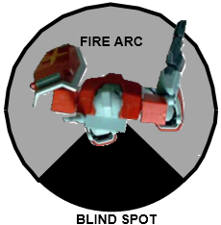

Mobile suits are capable of moving and shooting at the same time. Unless they using a heavy or ordinance weapon which they must remain still to shoot, the represents the suit bracing against the weapons recoil. If you are moving at the firing at the same time this effects targeting due the suit jolting – the faster you go the harder it becomes to target your enemy. Of course this works the other way too the faster you go the harder it is for your enemies targeting system to get a lock on you.

|  |
| --- |
| **Modifiers** |
| +1 if the target/firer is stationary |
| -1 if the target/firer moves up to 6” |
| -2 if the target/firer moves up to 12” |
| -1 if the target is in quarter cover |
| -2 if the target is in half cover |

When firing work out if the weapon is in range, find the score you need to hit and roll a D6 then apply the following modifiers. If the modifiers take you below the to-hit score you fail to hit your target. If the modifiers take you above the to-hit score then you hit. As long as you make the to-hit roll you will hit your target. These modifiers are accumulative also don’t forget to check your weapons profile as they normal have a modifier to apply according the range to the target.

**The Rule of One and Six**

You may notice looking at the modifiers there are times when you won’t be able to hit your target. Or that you BS skill of the pilot you’ve chosen makes it almost impossible to miss. This is where the rule of One and Six comes in, a roll of a One on a D6 always misses regardless of modification and roll of a Six always hits regardless of modification.

**Six followed by a Six, then another Six**

Space is merciless environment to fight in, the lightest piece of damage can spell disaster as internal works are exposed to the environment. And even the lightest caliber weapon can A Six to hit, followed by another Six rolled on a D6 results in a critical hit. Roll another dice on a 1-5 the critical is taken on the Glancing hit chart, on a Six its taken on the Penetrating hit chart.

**Shield Saves**

Almost all Mobile Suits have a layered armored shield of some description mounted on a arm or shoulder. This shield gives the Suit a degree of protection against enemy fire. A pilot can choose to take any hit – with the exception of Ordinance – on his shield if the shot is in his frontal fire arc. The shield save is 4+ on a D6, if he fails the role for armor penetration as normal. Remember shields can be used in close combat as well to ward off enemy blows

Warning! *Armored shields are very tough, put can only take so much punishment before they give. On a roll of a one regardless of shield type it cracks or shatters and is effectively useless for the rest of the game.*

**Cover Saves**

Space is vicious place to have a fire fight, with almost no LOS restrictions and the enemy can come from any direction. Cover is still vital to a Pilots survival in space. If a Mobile suit is within 6” of piece debris, asteroid, Mobile suit, Mobile armor. The Pilot can claim cover and gets the modifier depending on how much of his suit is covered.

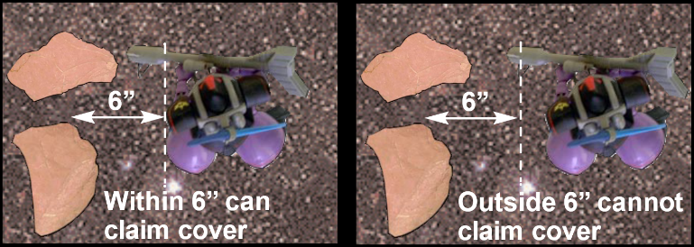

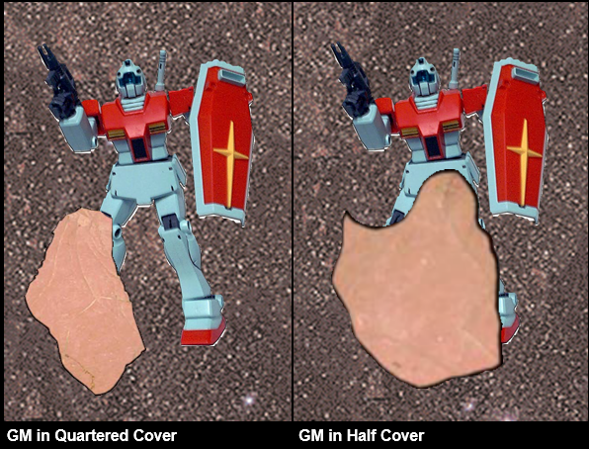

**Armor Penetration**

Once a hit is scored against a Mobile Suit roll a D6 and add the weapons Strength characteristic to it. Then compare it against the total of the Mobile Suits Armor value. Ordinance weapons fire such a huge projectile that they can smash apart armor with ease or turn the pilot to mush with the concussive force. When you roll for an Ordinance penetration roll two dice and pick the highest result.

If the total is less than the Suits armor value the shot bounces off.

If the total is equal to the Suits armor value the shot causes a glancing hit.

If the total is greater than the Suits armor value the shot causes a penetrating hit.

For Example. *The GM’s 100mm hits the Zaku twice on the front armor arc, the Zaku pilot makes his shield save for one of the shots, but the other makes it through. The GM pilot roles for penetration. The armor value of a Zaku’s front armor is 12. Rolling a D6, the pilot scores a 4, and adds this to the 100mm strength of 6 for an armor penetration total of 10. This is less than the armor value of the Zaku and so the shot bounces off.*

**Mobile Suit Armor Value**

Armor Values are different on each type of Suit. They represent the strength and thickness of the alloy used to armor up the Suit. Armor values on Mobile Suits also differ depending on whether the shot hits the front, side or rear.

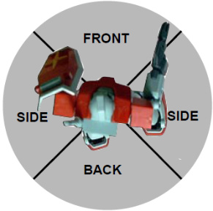

**Pilot Concussion**

Mobile Suits can absorb a great amount of damage before collapsing. However the pilots inside cannot and they suffer the effects of the concussive force of the weapons used against them. Any hit that scores an armor penetration total of 11 or more regardless of penetration the pilot must take a PS roll or count as stunned next turn. Concussion is ignored if the pilot is in close combat as the desperation to stay alive overrides any pain caused.

**Damage Rolls**

If the Mobile Suits armor is breached make a Damage roll to see what happens. Roll a D6 and look up the result on the appropriate Damage Table. Please note there are separate Damage tables for glancing and penetrating hits and these are different to the ones in the Ground War rules.

*Note on Stun and shaken results – Do not add them together you can only get stunned and shaken once per turn. These results are not accumulative.*

*Note on Immobilized results – An immobilized suit cannot turn in place and if it received a second immobilized result its weapon are jammed pointing in the direction they last fired. Weapons jammed in place can only fire at units directly in their line of fire. A third result and the suit cannot fire any weapons and counts as destroyed (result four on the chart) for the rest of the game.*

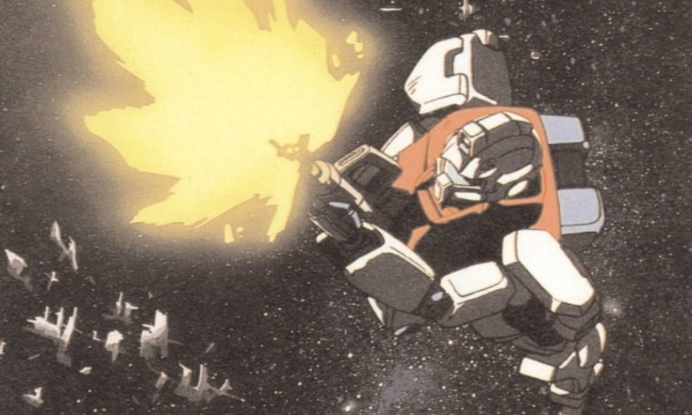

|  |
| --- |
| Glancing Hit Table – Roll a D6 |
| 1 Shaken – May not shoot next turn |
| 2 Stunned - May not shoot and the Mobile suit moves out of control in a 3D6 random direction next turn. Can make shield saves as normal. |
| 3 Limb Destroyed – Roll a D61-3 Leg - Suit loses 3” movement for each leg destroyed4-6 Arm -Suit loses 2” movement of each arm destroyed Roll a D6 to determine which arm and then apply the effect1-3 Left Arm – Shield destroyed4-6 Right Arm – Weapon destroyed |
| 4 Weapon Destroyed – A weapon chosen by the opponent is destroyed and can no longer be used |
| 5 Vernier Hit – Roll a D6. On a 4+ the boosters do not work this turn. The suit moves at the same speed as last turn and in the same direction. If the suit leaves the table it counts as destroyed for Victory point purposes. |
| 6 Auto-Balance Destroyed - Not that important in space, but it is keyed into the suits inertia systems. All movement remains the same the Pilot counts as stunned as he attempts to control of the suit. |

|  |
| --- |
| Penetrating Hit Table – Roll a D6 |
| 1 Vernier Hit - Roll a D6 on a 4+ the boosters don’t work this turn. The suit moves at the same speed as last turn and in the same direction. If the suite leaves the table it counts as destroyed for Victory point purposes. |
| 2 Auto-Balance Destroyed - Not that important in space, but it is keyed into the suits inertia systems. All movement remains the same the Pilot counts as stunned as he attempts to control of the suit. |
| 3 Limb Destroyed – Roll a D61-3 Leg - Suit loses 3” movement for each leg destroyed4-6 Arm -Suit loses 2” movement of each arm destroyed. Roll a D6 to determine which arm and then apply the effect1-3 Left Arm – Shield destroyed4-6 Right Arm – Weapon destroyed |
| 4 Head destroyed – Suit can only see using its Gun Camera, all movement is halved and WS, BS & I are at -2 |
| 5 Disabled - Suit is a junked heap - the suit will drift at 2d6” in the last direction it faced until it leaves the table or is destroyed. |
| 6 Destroyed - Suits reactor is hit and goes nova. The resulting explosion causes a 3D6 radius blast measured from the center of the Suit. Any Mobile Suit or caught in the explosion suffer a glancing hit on a 2+ and a penetrating hit on a 5+. Fighters roll on their damage table on a 3+ if they are caught in the explosion. |

# Mobile Suits in Assaults

Mobile Suits fight a little differently in space, follow the rules as described in the Warhammer 40,000 rulebook. With the following exceptions.

**Hit & Run**

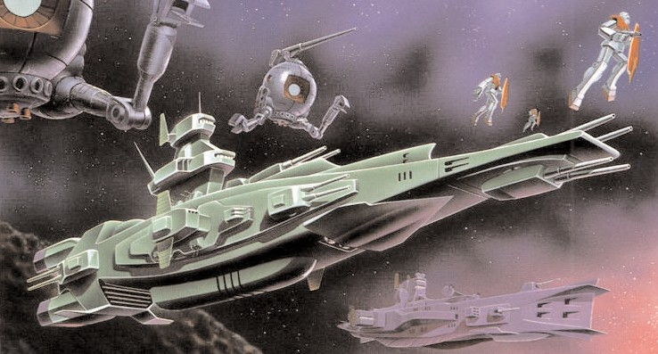

After each round of close combat, the suits move apart 4" and count as disengaged from combat. This means the suits can move as normal next turn. This represents the more hit and run nature of close combat in space.

**Immobilized**

Suits that are immobilized can still fight as normal. Their attack characteristic is reduced by –1 for each Immobilized result received.

**Hand-to-Hand Multiple Combats**

There are occasions were a Mobile Suit is up against more than one opponent. Pilots may choose to split their attacks against their opponents or concentrate on one assailant.

**Losing Combat**

If neither Mobile Suit hasn’t been destroyed in the resulting combat. Then the Mobile Suit that has scored the largest number of hits (that’s hits, they don’t have to penetrating or glancing hits) will win the combat (imagine the opponent being driven back by the series of blows).

His opponent has to make an immediate leadership test or Fall Back against his opponent. If the combat is a draw roll for Morale High ground as normal.

**Fall Back & Crossfire**

If a Mobile Suit Pilot fails his leadership role he will retreat in the same way as described in the Core rulebook. Note you cannot crossfire a Mobile Suit and if pursued, and caught the pursuing Pilot get a free back against the rear armor. If the pursued suit survives this free attack he has to turn and face his attacker again.

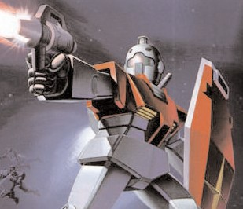

**Close Combat Weapons**

Mobile Suits are usually armed with close combat weapons be it Beam sabre or Heat Hawk. These weapons add their own bonuses onto the strength of the Suit. So when you hit work out penetration as normal. A Mobile suit armed with two close combat weapons gains an extra attack, but cannot use its shield save.

**Additional Close Combat Weapons**

Although some suits are armed with two close combat weapons, like for example 2 Beam Sabres. Mobile suits lack the basic automated coordination needed to use both weapons at the same time. A Mobile Suit can only use one Beam Sabre at a time.

*Good luck Pilots, check your weapons and stay sharp. You are ready to start fighting in unforgiving climate of Space. Be sure to check out Fighter rules and the Federation & Zeon Space Force list for your Suit specs and your pilot’s abilities. Use your forces wisely and watch your six Commander. That is all*

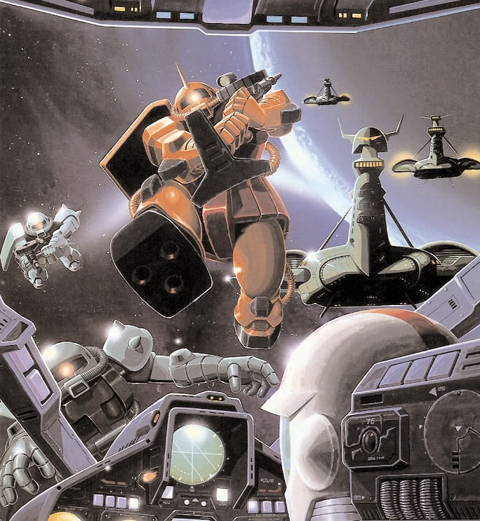

# A Brief Introduction - Using the Flight List

The Mobile Suit List is structured a little different to regular Warhammer 40,000 lists. It is split into two sections (a lot like the Armored Company list in Chapter Approved): the army list and the Mobile Suit Hanger. You use the Army list to pick the Pilots you want to make up your Team and then use the Mobile Suit Hanger to decide what type of suit your Pilot would be jockeying.

The reason for this system is simple – many of the Pilots on the list can pick from a number of different types of Mobile Suit. This cuts down repetitive in the list and makes it a lot shorter.

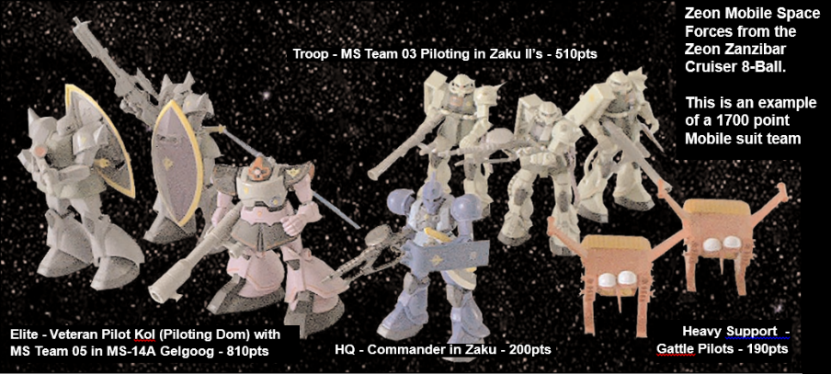

The army list are used in conjunction with the Standard Mission force organization chart in the Core rulebook. The chart is split into five categories (HQ, Elites, Troops, Fast Attack and Heavy Support), which correspond to sections in the army list. To choose your pilot you need to look in the relevant section of the list. The entry will also tell you what types of mobile suit can be chosen for that pilot from the Mobile Suit Hanger. Refer to the Hanger to find the points cost of the Mobile Suit and the weapon options and upgrades you can get for it. Remember you cannot field Suits that are equipped with the weapons or upgrades not shown on the Mobile Suit model.

The total points cost for the unit is equal to the points noted for the Suit and its upgrades in the hanger, plus the points for the pilot in the army list. Subtract this total from your army’s total points, and then go back and make another choice. Continue to do this until you have spent all your points. Then get ready to rumble…

Important Note: The Mobile suits add additional bonuses to the Pilots profile make sure you note these on the Pilots profile, don’t forget to replace the pilots strength with the Mobile Suits strength while he is piloting the machine. Also note that Mobile suits can only be armed with one hand held mobile suit weapon system. Many Mobile Suits found in

# Earth Federation Space Force

The Earth Federation Space Forces Mobile suit division is organized much along the same lines as their land counterpart. They are usually based on a Mobile Carrier or a retro-fitted Federation warships in units called Wings. These Wings usually are made up of a maximum of three Mobile Suits (some ships like Mobile Carriers usually have a two Mobile suit Wing compliment). Like the land equivalents these wings are led by a Commander and they undertake patrol duties, engage and destroy missions, and even decoy missions.

The list below is designed to reflect the nature of a Mobile Suit Wing and any support units that might be assigned to them to complete their mission – such as Ball units or Star-fighters. It includes units that participated in the earliest Federation counterattacks in space as well as rarer specialist suits which made their debut in the final days of the One Year War.

# Earth Federation Space Forces

# Headquarters – Flight Leader

|  |  |  |  |  |  |  |  |  |  |
| --- | --- | --- | --- | --- | --- | --- | --- | --- | --- |
|  | **WS** | **BS** | **S** | **W** | **I** | **A** | **PS** | **LD** | **PV** |
| Ensign | 3 | 4 | 4 | 1 | 3 | 2 | 8 | 8 | 25 |
| Lieutenant | 4 | 4 | 3 | 2 | 4 | 3 | 8 | 8 | 35 |
| Captain | 4 | 4 | 3 | 3 | 5 | 4 | 8 | 9 | 50 |

**Unit Size:** *One Suit*

**Mobile Suit Options:** *RX-78 Gundam, RGM-79 GM, RGM-79G GM Command, RGM-79GS GM Command Space Type, RGM 79L GM Light Armor, Core Fighter, Core Booster, or RB-79 Ball*

**Independent Character:** *The Flight Leader is an Independent Character and follows the independent character special rules in the Universal Special Rules section of the Core Rules.*

# Elite – Veteran Pilot

|  |  |  |  |  |  |  |  |  |  |
| --- | --- | --- | --- | --- | --- | --- | --- | --- | --- |
|  | **WS** | **BS** | **S** | **W** | **I** | **A** | **PS** | **LD** | **PV** |
| Veteran Pilot | 3 | 4 | 3 | 1 | 3 | 2 | 8 | 7 | 20 |

**Unit Size:** *One Suit*

**Mobile Suit Options:** *RX-79, RGM-79 GM, RGM-79G GM Command, RGM-79GS GM Command Spade Type, , RGM 79SC GM Sniper Custom, RGM 79SP GM Sniper II, RGM 79L GM Light Armor, RB-79 Ball, Core Fighter, or Core Booster*

**Independent Character:** *The Flight Leader is an Independent Character and follows the independent character special rules in the Universal Special Rules section of the Core Rules.*

# Troops – Pilot

|  |  |  |  |  |  |  |  |  |  |
| --- | --- | --- | --- | --- | --- | --- | --- | --- | --- |
|  | **WS** | **BS** | **S** | **W** | **I** | **A** | **PS** | **LD** | **PV** |
| Pilot | 3 | 3 | 3 | 1 | 3 | 2 | 7 | 7 | 15 |

**Unit Size:** *One Unit*

**Mobile Suit Options:** *RGM-79, Core Fighter, Core Booster, or RB-79 Ball*

**Mutual Support:** Pilots are trained to work in concert with each other and are often too inexperienced to operate alone. Therefore Pilots must always attempt to remain within 8” of another MS unit or suffer a -1 to all Leadership tests.

# Heavy Support – Support Pilot

|  |  |  |  |  |  |  |  |  |  |
| --- | --- | --- | --- | --- | --- | --- | --- | --- | --- |
|  | **WS** | **BS** | **S** | **W** | **I** | **A** | **PS** | **LD** | **PV** |
| Artillery Pilot | 3 | 4 | 3 | 1 | 3 | 1 | 7 | 7 | 20 |

**Unit Size:** *One Suit*

**Mobile Suit Options:** *RGM-79 GM, RX-77 Guncannon, RX-77D Guncannon Mass Production Type, Core Fighter, Core Booster, or RB-79 Ball*

# EFSF Mobile Suit Hangar

A number of mobile suits which participated in the Ground War on Earth also saw use in space. These suits’ profiles are already included in the MSGBS Core rules. They maintain the same point values and options listed in the Core Rules. Their space movement values are listed below.

|  |  |
| --- | --- |
| **Core Rules Suit Movement Values** | |
| RGM-79 GM | 12” |
| RX-78-2 Gundam | 18” |
| RX-77-2 Guncannon | 10” |

Other late war suits useable in the ESFS Army List may be found in the Codex 0080 expansion. Those suits include space movement values already in their entries.

# RGM-79 [E] GM Early Type

During the chaotic One Year War, the Federation attempted to mass-produce a mobile suit to combat the Principality of Zeon's fearsome MS-06 Zaku II. With the RGM-79［G］ GM Ground Type already deployed on Earth, the RGM-79[E] GM Early Type would be deployed in space. The RGM-79[E] GM Early Type is an early model GM mobile suit used as a test machine to gather data for the Earth Federation's first true future mass production mobile suit. The RGM-79[E] GM Early Type's equipment was optimized for use in space. 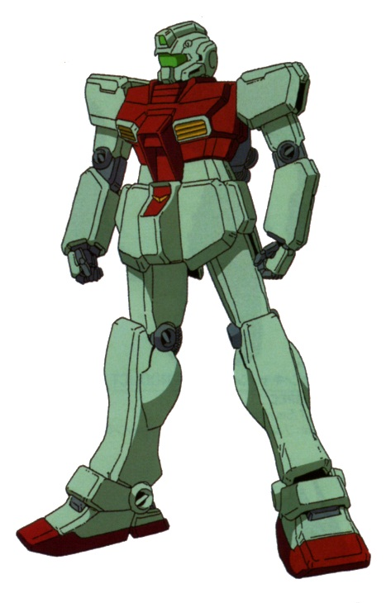

|  |  |  |  |  |  |  |  |  |  |  |  |
| --- | --- | --- | --- | --- | --- | --- | --- | --- | --- | --- | --- |
|  | **WS** | | **BS** | **S** | | **W** | **I** | | **A** | **PS** | **LD** |
| Pilot Bonus | - | | - | 5 | | - | - | | +1 | +1 | - |
| **Armor Values** | | **Front** | | | **Side** | | | **Back** | | | **PV** |
| RGM-79 [E] | | 11 | | | 10 | | | 9 | | | 100 |

**Move Value** – 14”

**RGM-79 [E] GM Early Type Standard equipment & weapon:**

Twin-linked 60mm Vulcans, two beam sabres & shield

**RGM-79 [E] GM Early Type Optional equipement & weapons:**

Targeter (+5pts), beam pistol (+20pts) or 90mm machine gun (+25pts).

# FF-X7 Core Fighter

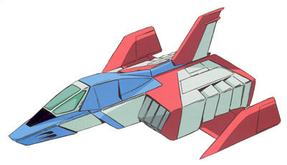 The FF-X7 Core Fighter was developed as part of the [Earth Federation](http://gundam.wikia.com/wiki/Earth_Federation)'s [Project V](http://gundam.wikia.com/wiki/Project_V) as mobile suit cockpits and emergency escape craft to increase pilot survivability and to safeguard data acquired the Earth Federation's original nine combat ready mobile suit, of which only three participated in the war. Aside from their original purpose the Core Fighter could be used as a support craft to aid mobile suit in battle either in space or in the Earth's atmosphere. Though effective fighters against the [Principality of Zeon](http://gundam.wikia.com/wiki/Principality_of_Zeon)'s [Dopp Fighters](http://gundam.wikia.com/wiki/Dopp_Fighter) and [Magella Attack Tanks](http://gundam.wikia.com/wiki/Magella_Attack_Tank) they would have limited effectiveness during the war.

|  |  |  |  |  |  |  |  |  |  |  |  |
| --- | --- | --- | --- | --- | --- | --- | --- | --- | --- | --- | --- |
|  | **WS** | | **BS** | **S** | | **W** | **I** | | **A** | **PS** | **LD** |
| Pilot Bonus | - | | - | - | | - | - | | - | - | - |
| **Armor Values** | | **Front** | | | **Side** | | | **Back** | | | **PV** |
| FF-X7 Core Fighter | | 5 | | | 5 | | | 5 | | | 55 |

**Move Value –** 20”

**FF-X7 Core Fighter Standard equipment & weapons:**

Twin Linked 25mm Vulcan Gun, Twin Linked X7-Missile Launcher and Twin Linked Mega Particle Cannon.

**FF-X7 Core Fighter**